We Just Met Yesterday

**Sensor Package Prototype V3**

Assembly Instructions

**Box Bottom Half**

1. Drawing **P-2** provides the annotated drawing for the Box Bottom Half. This Box is an “Aluminum Corrosion-Resistant Washdown Enclosure” from McMaster that will be custom fit to this prototype.
2. If you do not have machining experience, the Montgomery Machining Mall or Makerspace machining staff can provide machining help to cut the necessary slots into the box.

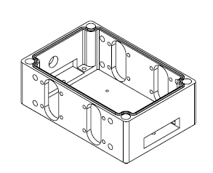

*Fig. 1: Isometric View of Box Bottom Half*

**Procurement**

1. All items can be found in the Parts List at the beginning of the Drawing and Fabrication Package.
2. Links are provided to order them from McMaster or other vendors. Many of these parts are available at Home Depot as well, provided attention is paid to their correct sizes.

**PCB**

1. Drawing **P-3** provides the PCB Board Layout and Schematic Layout. These files are available digitally in the project files.
2. If you do not have prior PCB manufacturing experience, the [Electronics Lab](https://www.me.gatech.edu/facilities/electronic_lab), on the first floor of the MRDC, can use the schematic and board layout files to manufacture it for you. You can speak with their engineers in the lab to validate the board, and you can submit it online via the [Electronics Lab Technical Request Form](http://electronicslab.me.gatech.edu/request/request.php) for manufacturing.

**Box Bottom Half - continued**

1. As seen in Fig. 3, these slots have a radius of 0.40” and a length of 1.10” between each circle’s center. Cut these slots, based on their locations in Fig. 3, from both long-sides of the box.

*Note: These slots are symmetric, so the length from the left slot’s center to the left side of the box matches the length of the right slot’s center to the right side of the box*.

1. Locate the LIDAR mounting holes, located next to the LIDAR slots, as seen in Fig. 4.

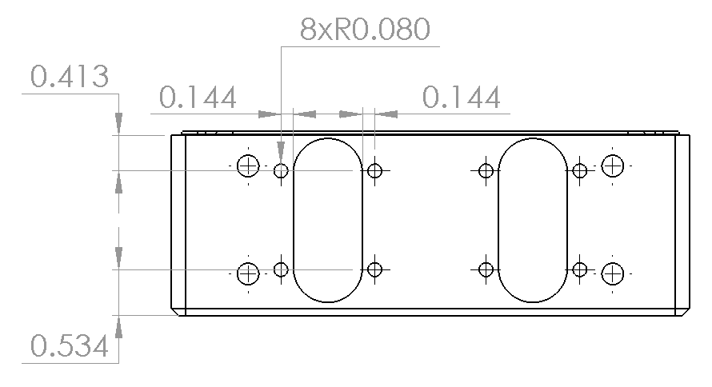

*Fig. 4: Locations of LIDAR Screws*

**Box Bottom Half - continued**

1. Drill 4 holes for Size 4 Screws in the bottom of the box. These will serve as mounts for the Raspberry Pi. The hole locations are found in Fig. 2.

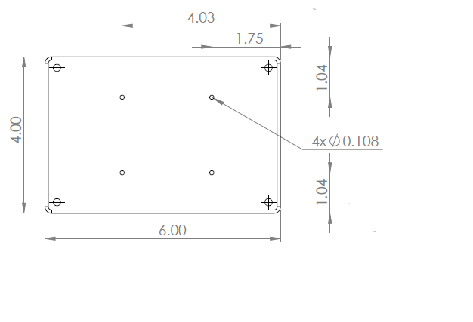

*Fig. 2: Locations of RaspPi Screws*

1. Locate the cut locations for the LIDAR slots. These are referenced in Fig. 3 below.

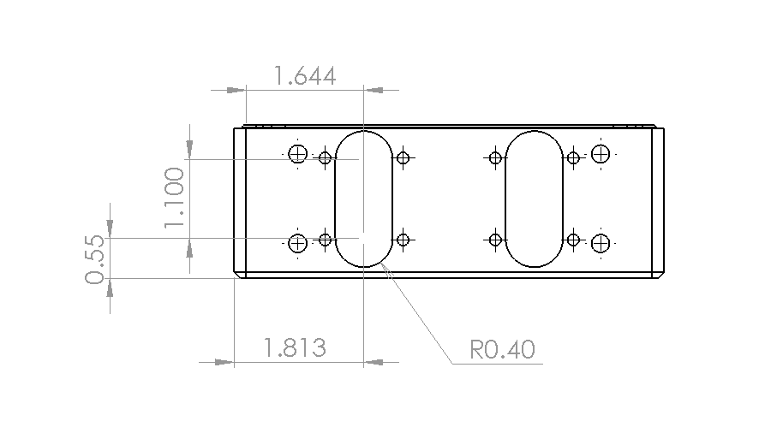

*Fig. 3: LIDAR Slot Locations*

**Box Bottom Half - continued**

1. Select one of the short-sides of the box to be the Back. Either side works as the box is currently symmetrical.
2. Locate the switch hole in Fig. 6.

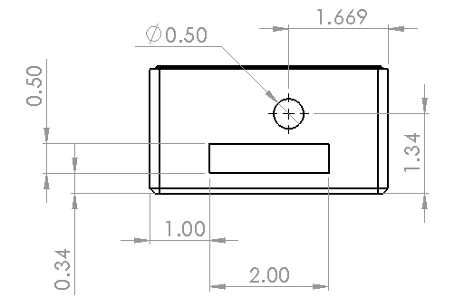

*Fig. 6: Back of Box*

1. Drill a 0.50” hole at this location. If a different switch is used, size this hole to that switch.

*Recommended: A slot in the Back, shown above, and another in the Front were designed to improve accessibility to wiring inside the box and to promote cooling, if needed. It is recommended to cut these and use plastic sheets to cover when not needed.*

**Box Bottom Half - continued**

1. Drill these LIDAR mounting holes for size 6 screws. Hole diameter of 0.16” is suitable (matching the LIDAR’s hole diameter).
2. Repeat these holes for each LIDAR mount. There should be 16 total holes after this step.
3. Locate the U-bolt mounting holes, detailed in Fig. 5.

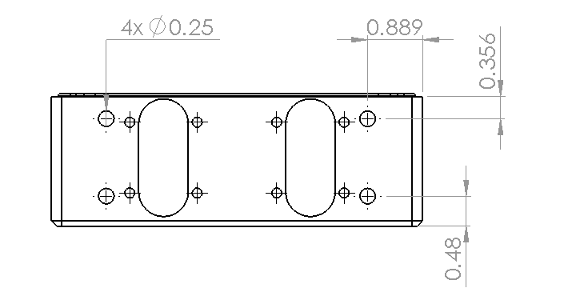

*Fig. 5: Locations of U-bolts*

1. Drill 0.25” holes. There should be 8 total.

**Box Top Half**

1. Orient the box to its Front face. Locate the slot, shown in Fig. 8.

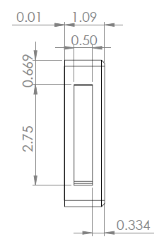

*Fig. 8: Front Face Slot*

1. Cut slot into the face. This helps with cooling and is likely necessary to fit the wires leading to the battery.

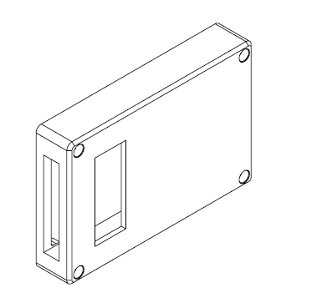

*Fig. 9: Box Top Half*

**Box Top Half**

1. Determine a Front Side of the Top Half. Orient the Box to the Top Face and locate a viewing slot as described in Fig. 7.

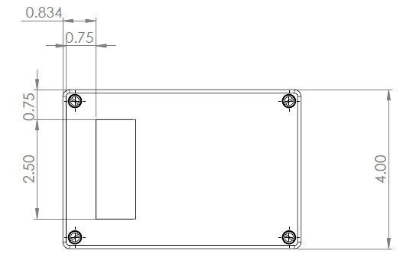

*Fig. 7: Top Viewing Slot*

1. Cut viewing slot into the box. This is to monitor the battery’s status when installed. Check where you will place battery before making the cut to make sure it is in the right place. Use a plastic-sheet to seal the window.

**Package Assembly - continued**

1. Insert the U-bolt into its holes to the outside of the LIDAR.

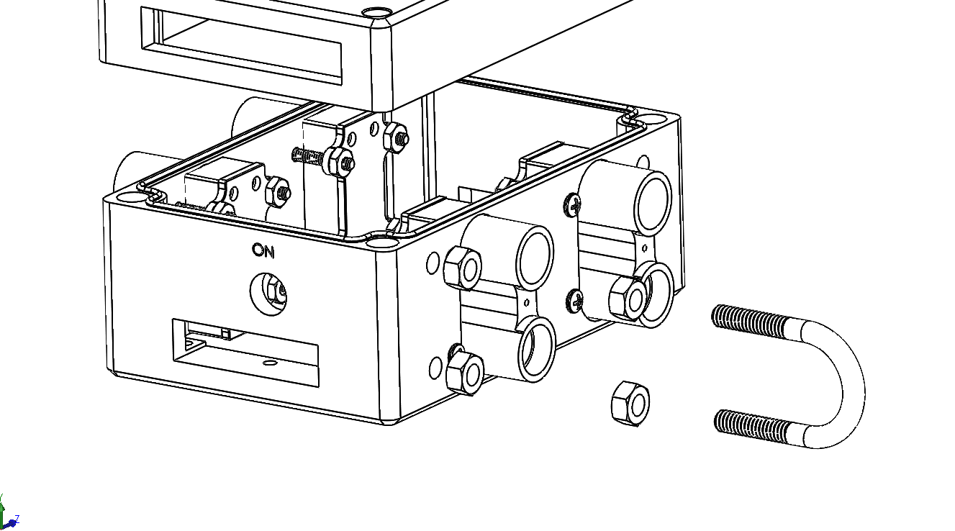

1. Tighten 2 more nuts (O-16) around the U-bolt inside the box, securing it to the sides.
2. Repeat until all 4 U-bolts are installed.

**Package Assembly**

1. Insert the LIDAR (O-5) into their slots from inside.
2. Insert screws (O-6) from the outside, running all the way through, and tighten nuts (O-7) around the end.

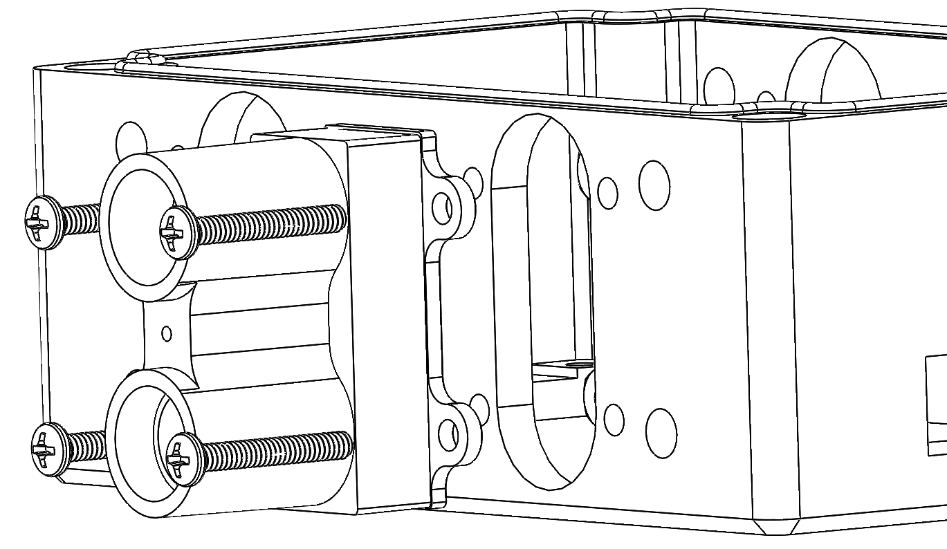

*Note: The excess screw tip may need to be cut shorter to fit the Raspberry Pi in later. Alternatively, the screws can be flipped so that their head is inside the box.*

1. Repeat until all 4 LIDAR are installed.
2. Add 2 nuts (O-15) to the U-bolt (O-15), tightening or loosening to extend the U-bolt past the LIDAR.

**Package Assembly - continued**

1. Tighten the nut and secure the Rasp Pi to the box.
2. Place the PCB (P-3) on the Arduino (O-13). Wire the Arduino to the Rasp Pi. Place the Arduino on top of the Rasp Pi, with a thin plastic sheet between the Pi and any insulation laid between both devices.

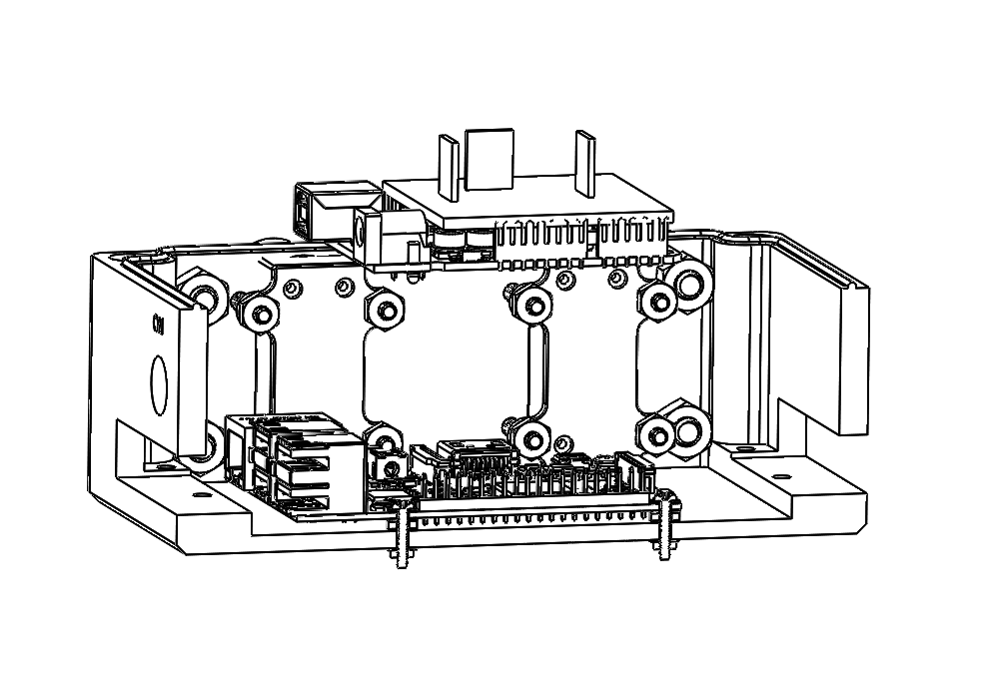

1. Attach the switch (O-17) to the box.

**Package Assembly - continued**

1. Prepare to insert the Raspberry Pi (O-8) and secure it with the following parts. From top to bottom, they will attach as follows:
   1. Screw (O-11)
   2. Washer (O-9)
   3. Rasp Pi (O-8)
   4. Washer (O-9)
   5. Spacer (O-10)
   6. Washer (O-9)
   7. Box Bottom (P-2)
   8. Washer (O-9)
   9. Nut (O-12)

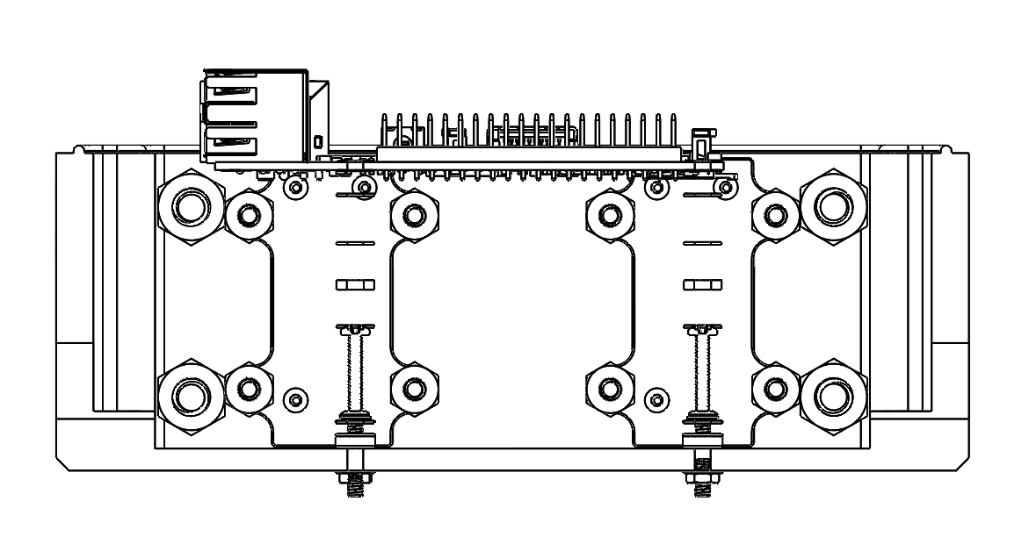

**Package Assembly - continued**

1. Attach the switch (O-17) to the box.

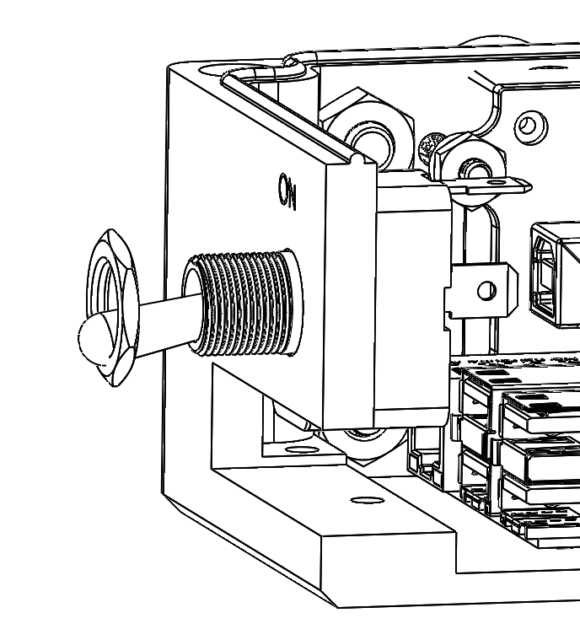

1. Wire the switch to the PCB.
2. Wire the LIDAR to the PCB.
3. Secure the battery (O-14) with adhesive to the Box Top Half (P-1).

*Note: More permanent means can be used on the battery if desired. However, given that it was never tested with the package or orientation, more temporary tape was preferred for now.*

1. Wire Battery to the PCB and devices.